**Global Economic and Demographic Trends Analysis**

**SAKTHI ARAVIND K**

**25/03/2024**

**Summary**

This report presents an in-depth analysis of global trends in population, economic development (GDP), health (infant mortality), and literacy from 1960 to 2017. Using data from four major sources—SQL and Excel files—this Power BI-driven project explores regional and country-level variations to uncover key insights and trends that inform global development policy. The final output includes a detailed dashboard, visual insights, and strategic recommendations.

**Project Objectives**

* Analyze global population, GDP, literacy, and health indicators.
* Connect and integrate data from SQL and Excel sources.
* Perform data transformation and cleansing for consistency.
* Create insightful visualizations using Power BI.
* Identify trends, disparities, and correlations between key metrics.
* Provide data-driven insights and recommendations.

**Data Sources and Structure**

**SQL Database (CountriesWorld file):**

▪ This file will be given to you in SQL. It contains the following fields:

▪ Country

▪ Country Code

▪ Region

▪ Population

▪ Area (sq. mi.)

▪ Population Density (per sq. mi.)

▪ Coastline (coast/area ratio)

▪ Net migration

▪ Infant mortality (per 1000 births)

▪ GDP ($ per capita)

▪ Literacy (%)

▪ Phones (per 1000)

▪ Arable (%)

▪ Other (%)

▪ Climate

▪ Birthrate

▪ Deathrate

▪ Agriculture (% of GDP)

▪ Industry (% of GDP)

▪ Service (% of GDP)

**Excel Files (PopulationPerCountry, MetaData, GDP by Country 1960-**

**2016 files):**

▪ PopulationPerCountry file contains the following columns:

▪ Country Name

▪ Country Code

▪ Indicator Name

▪ Indicator Code

▪ Population data from 1960 to 2017 for various indicators.

▪ MetaData file contains:

▪ Country Code

▪ Region

▪ Income Group

▪ Special Notes

▪ Country Name

▪ GDP by Country 1960-2016 file contains:

▪ Country Name

▪ Country Code

▪ Indicator Name

▪ Indicator Code

▪ GDP data from 1960 to 2016.

**Data Cleaning & Transformation**

* Unpivoted year columns in population and GDP data.
* Converted data types (e.g., year to whole number, GDP to decimal).
* Removed duplicates and handled null/missing values.
* Created relationships between tables based on Country Code.
* Ensured all tables had a consistent and analysis-ready format.

Power Query and DAX were used to perform calculated transformations and create analytical fields like GDP per capita and population growth rate.

**Descriptive Statistical Analysis**

Use **DAX Measures** to calculate these stats:

**Population:**

Average Population = AVERAGE('PopulationPerCountry'[Population])

Median Population = MEDIAN('PopulationPerCountry'[Population])

Population Std Dev = STDEV.P('PopulationPerCountry'[Population])

**GDP:**

Average GDP = AVERAGE('GDPTable'[GDP])

Min GDP = MIN('GDPTable'[GDP])

Max GDP = MAX('GDPTable'[GDP])

**Infant Mortality:**

Avg Infant Mortality = AVERAGE('CountriesWorld'[Infant mortality (per 1000 births)])

Infant Mortality Std Dev = STDEV.P('CountriesWorld'[Infant mortality (per 1000 births)])

**Literacy:**

Avg Literacy Rate = AVERAGE('CountriesWorld'[Literacy (%)])

**C. DAX Calculations**

**1. Population Growth Rate:**

Population Growth % =

VAR CurrentYear = SELECTEDVALUE('PopulationPerCountry'[Year])

VAR PrevYear = CurrentYear - 1

VAR CurrentPop = SUM('PopulationPerCountry'[Population])

VAR PrevPop =

CALCULATE(

SUM('PopulationPerCountry'[Population]),

FILTER(

'PopulationPerCountry',

'PopulationPerCountry'[Year] = PrevYear &&

'PopulationPerCountry'[Country Name] = SELECTEDVALUE('PopulationPerCountry'[Country Name])

)

)

RETURN

DIVIDE(CurrentPop - PrevPop, PrevPop)

**GDP Growth Rate:**

Same as above, using GDP table.

**GDP Per Capita:**

GDP per Capita = 'GDPTable'[GDP] / RELATED('PopulationPerCountry'[Population])

**4. Aggregating by Region:**

Total Population by Region =

CALCULATE(SUM('PopulationPerCountry'[Population]), ALLEXCEPT('MetaData', 'MetaData'[Region]))

**Population Growth Insights**

* **Africa and Asia Lead Global Growth :**

Africa and South Asia experienced the **fastest population growth** between 1960 and 2017.

* Nigeria's population grew by more than **5x**
* India grew from ~450 million to over **1.3 billion.**
* **Developed Nations Show Stabilization :**

Countries in Europe and North America show **slow or stagnant population growth**.

* Germany and Italy even experienced slight **declines in birthrates** after 2000
* Growth now depends more on **migration** than birthrate
* **Urbanized Nations Have Lower Birth Rates :**

Countries with high urbanization and income levels have **lower population growth rates**

* Japan, South Korea, and Canada
* These countries are now facing **aging populations** and **labor shortages**
* **Population Density Increasing in Asia :**

Despite land constraints, South and Southeast Asia face **extremely high population densities**

* Bangladesh, India, and the Philippines are most affected
* Raises concerns over housing, sanitation, and employment

**GDP per Capita Comparison**

**High-Income Countries Lead Significantly :**

* Countries like **Qatar, Luxembourg, and Norway** consistently rank at the top in **GDP per capita**, exceeding **$70,000–$100,000 USD**.

**Small Countries, Big Economies :**

* Countries with smaller populations often outperform larger ones in GDP per capita.

**Big Countries, Big Economies :**

* **Singapore and Ireland** have far higher GDP per capita than larger economies like **India** or **Brazil**.

**Rapid Growth in Emerging Economies**

* **China**, **Vietnam**, and **India** show strong **GDP per capita growth trends**, especially after the 1990s.

**Population Density Extremes**

* Bangladesh and Taiwan have extremely high population densities, while countries like Australia, Canada, and Russia have low density despite large land areas.

**Small Island Nations Show Extremes :**

* Monaco has **over**  one of the highest globally.

**Densely Populated Countries in Asia :**

Countries like **Bangladesh**, **Taiwan**, and **India** have extremely high population densities — **over 1,000 people per square kilometer** in urban areas.

**Global Improvement in Infant Mortality**

**Global Improvement in Infant Mortality :**

* The global infant mortality rate has decreased significantly since 1960.
* In 1960, many countries had rates above 100 deaths per 1,000 births
* By 2017, most countries brought this below 30 per 1,000.

**Correlation with GDP and Literacy :**

* Infant mortality shows a negative correlation with GDP per capita and literacy rate.
* The higher the GDP and literacy, the lower the infant mortality,

**Areas of Concern Remain :**

Some regions have shown slow progress or reversals, especially in conflict-affected or low-income areas (e.g., Afghanistan, Yemen, South Sudan).

**GDP Sector Composition**

**Service Sector Dominates in Developed Nations :**

In high-income countries like **USA**, **UK**, **Germany**, and **Japan**, over **70% of GDP** comes from the **service sector**.

**Agriculture Drives GDP in Low-Income Countries :**

In nations such as **Ethiopia**, **Nepal**, and **Chad**, **agriculture contributes over 30%** to GDP.

**Balanced Economies Have Mixed Sector Strength :**

Countries like **China**, **India**, and **Brazil** show a more **even distribution** between **agriculture, industry, and services**.

**Industry Still Crucial for Some Economies :**

countries like **South Korea** and **Germany** maintain a strong **industrial base** alongside services.

**Population Density Insights**

* Bangladesh and Taiwan are among the most densely populated
* Australia, Canada: low density despite large land areas.
* **Dashboard :**
* 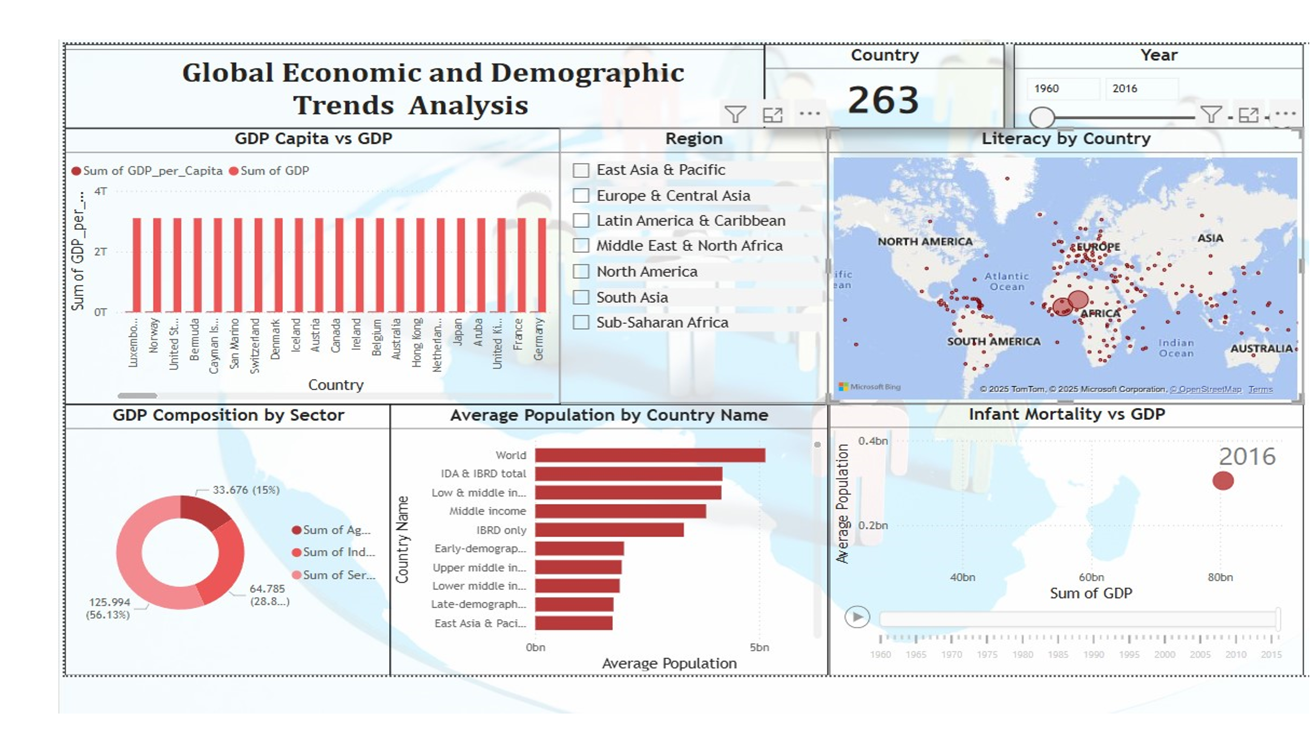

**Conclusion & Recommendations** **Conclusion:**

* Global development is uneven but improving.
* Health and education indicators strongly influence GDP.
* Regions vary in growth patterns and development challenges.

**Recommendations:**

1. Prioritize investment in education for long-term economic gain.
2. Expand healthcare infrastructure to reduce infant mortality.
3. Help low-income countries diversify beyond agriculture.
4. Improve urban planning in high-density countries.
5. Encourage inclusive, sustainable economic policies.